Curriculum Vitae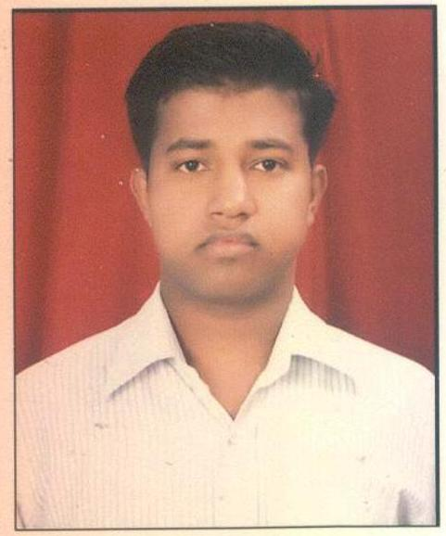

Pradyumna Kishor Khatua

Chakeisiani, Bhubaneswar, Dist-Khurdha

Odisha – 751010

**Mobile No. – +91-9015790557**

**mail-: Kishor.pkkpapu@gmail.com**

**CAREER OBJECTIVE:**

To work **honestly** in an organization that seeks an ambitious and career conscious person where acquired skills and education will be utilized towards continuous growth and advancement.

**PROFESSIONAL PREFACE:**

* Completed **Distance MBA in Marketing** from Vinayak Mission University with **around 9 years** of rich experience in TCI Supply Chain Solution a division of Transport Corporation of India Ltd.(TCI)
* Completed **B.sc (Math Hons)** from Utkal University (Odisha) in 2006.
* Warehousing and Distribution works of FMCG materials for **HINDUSTAN UNILEVER LTD.** worth daily transaction of 3-5 Crore rupees.
* Having around **9 years** of practical working experience of in **SAP R/3 (Sales & Distribution).**
* One year Diploma in Rail Transport Management
* And One year Diploma in Multimodal Transport and Logistics Management from Institute

of Rail Transport(IRT) .

**WORK EXPERIENCE**

Presently working with **Reliance Jio Infocomm Ltd** as a **SCM** (Sr.Executive)

(Date of 05/09/2017 to till Date)

Responsibilities:

* Maintaining of Inventory Reliance JIOwarehouse
* Maintaining of all kinds Stock Reports.
* Making GRN in SAP.(in different Servers Like P91,P447 And FIORI)
* Making Stock out in SAP. (in different Servers Like P91,P447 And FIORI)
* Follow up with courier partner for pick-up and Delivery.
* Generation of Delivery note and STN against the MR received through SAP.
* Maintaining & sending of all the Daily Stock reports, Dispatch Reports, Receipts report to the respective regional Commercial heads.
* Receiving of Stocks, Checking them physically, and stacking them as to Stacking Norms, Segregating as to Product, Value, Type, and Quality with Display Boards Indicating the product with all its positive & negative Issues.
* Conducting & Maintaining a Cycle Count check on a Weekly basis.
* Planning of Warehouse layout, space and storage optimization.
* Receiving of Stocks, Checking them physically, and stacking them as to Stacking Norms, Segregating as to Product, Value, Type, and Quality with Display Boards Indicating the product with all its positive & negative Issues.
* Generation of various sorts of MIS & TAT reports.
* Circulate closing Stock Value Reports of all stocks to the Corporate.
* Send all month end Reports (Inventory Report) to the circle SCM head.
* Circulate LMD Reports month wise to the Local SCM team.
* Circulate month end Ageing Reports of Handset, Revenue and marketing Stocks to the Corporate.
* Maintaining of all kinds of Revenue, Networking and, Marketing materials.

**PROJECT SERVE IN RELIANCE JIO**

1. Jio Phone,SIM,Router/Jiofi 2)Old Phone Exchange 3) Fttx Materials

**Previous Experience**

* 1 Year working experience as GIR & Invoice Operator.
* 2 Years of working experience as Inbound Manager
* 3 Years of Working experience as CSD & Water Co-ordinator
* 3 Years of working experience as a Lead **planner**

in HUL warehouse of Delhi Depot**(C&FA), Alipur**.

**RESPONSIBILITIES:**

* Check & resolve Completeness of customer Order & no drop of customer Order due to Hygiene Issues.
* Check all Deliveries which are block due to Pricing/Bom Qty Failure/Credit Issues and Highlight same to

Branch planner/CSE/RLM for correction and Avoid Reoccurrence of similar issues

* Follow up with Branch Planner Team for Price updation
* Ensure timely conversions as per instruction from Branch Planner/NCSC
* Ensure time execution of IDT/IBT given by Branch Planner.
* Drive CCFOT to minimize depot Controllable Losses.
* Analyze for allocation failure for available stock
* Analyze slow moving stock & inform Branch planner for necessary liquidation
* Analyze Expired stock inform Branch & SLOB incharge & follow up for movements
* Jointly work with WH Supervisor for ontime reconditioning of stocks if any at dept
* Impart Training to subordinates on SAP Functionalities/Planning Process/Order Execution.
* Maintain the FIFO,FEFO & LIFO Process
* Ensuring ambience and hygiene are maintained on the floor & on clds at all times
* Handling the Transporter for the delivery of materials in right time.
* Inventory management of warehousing stock.
* Internal Audit,Purchase,Procurement & Vendor Development

**Coordinate and monitoring:**

• Monitor Timely generation of loading slip & Submission to Warehouse team for physical operation including

IBT/IDT.

• Monitor Daily on time and correct reason entry in CCFOT Cube file

• Coordinate with Transport planner for timely placement of Trucks.

• Coordinate with SAP L1 Support team for closure of open issues related to SAP system.

• Coordinate with ICH Masters team for Preponement & Postponement of PDP orders in case of Depot Holiday

or issues under force measures (like Bandh/Strike/Climatical hindrances to run operation)

• Coordinate with Branch Planner / CSO for necessary liquidation stock > 50% shelf life

• Coordinate with Branch Planner / CSO / Quality Assurance team for Frozen, Transit Trail stock storage &

movement as per guidelines.

• Coordinate with Depot Administrator for record maintenance required for audit purpose

**Reporting:**

• Daily Hygiene loss report (To Branch Planner / CSO.)

• Daily CCFOT Report on HPC & F&B. (To CSO/Branch Planner)

• TDP report on slow moving / non moving inventory. (To Branch Planner)

**IT/SYSTEM SKILL SETS:**

|  |  |  |
| --- | --- | --- |
| **Skills** | **Years/Months of Experience** | **Proficiency** |
| **PGDCA**(Microsoft Fundamental, Ms DOS, MS-Office,  Web Browsing,Programming in Foxpro,Language in C & C++) from a private institute of Odisha(Orissa InfoTech) | 1 – Years | Expert. |
| **SAP Working knowledge (SD,MM)** | 11 – Years | Expert. |

* **Training (**With **Certificate) on “SAP ERP”** conduct by HUL IT in the area of HUL depot operation.

**ACADEMIC QUALIFICATION:**

* Completed **MBA (Distance)**  in marketing from *Vinayak Mission University,Tamilnadu in 2011*
* **B.Sc (Math Hons)** from *Utkal University*, Bhubaneswar, Odisha.2006
* **+2 Science** from *C.H.S.E* Bhubaneswar, Odisha in 2003
* **HSC/10t**h from *Board of Secondary Education Odisha* in 2001

**EXTRA CURRICULUM ACTIVITIES:**

* Positive thinking, ability to accept the challenges & knowledge System/Field operation.
* Sincerity and dedication along with strong work skills.

**Interest and Hobbies:**.

* Listening Odia Music and News .
* Reading Spiritual Books .

**PERSONAL DETAILS:**

**Permanent Address** : At-Kalinga, PO-Radhang, Via-Nalibar,

Dist-Jagatsinghpur, Odisha.

Pin-754104

**Date of Birth** : 24th April 1986.

**Nationality** : Indian.

**Languages Known** : English, Hind & Odia (Read, Write, Speak).

**Marital Status :** Married

**DECLARATION:**

I here by declare that all the above information furnished by me are true to the best of my knowledge and belief.

**Date:**

**Place**: **Signature** **of the Candidate**